**Ideation Phase**

**Empathize & Discover**

|  |  |
| --- | --- |
| Date | 25 May 2025 |
| Team ID | LTVIP2025TMID28869 |
| Project Name | Educational Organisation using Servicenow |
| Maximum Marks | 4 Marks |

**Empathy Map Canvas:**

The Empathy Map Canvas is a useful tool for educational organizations leveraging ServiceNow to better understand the needs and experiences of their students, faculty, and staff. By mapping what users say, think, do, and feel, institutions can identify pain points and opportunities for service improvement. Integrated with ServiceNow’s workflow and case management capabilities, the empathy map guides the design of more human-centred IT support, facilities management, and student services. This helps create a more responsive, intuitive, and personalized campus experience.

# Example:

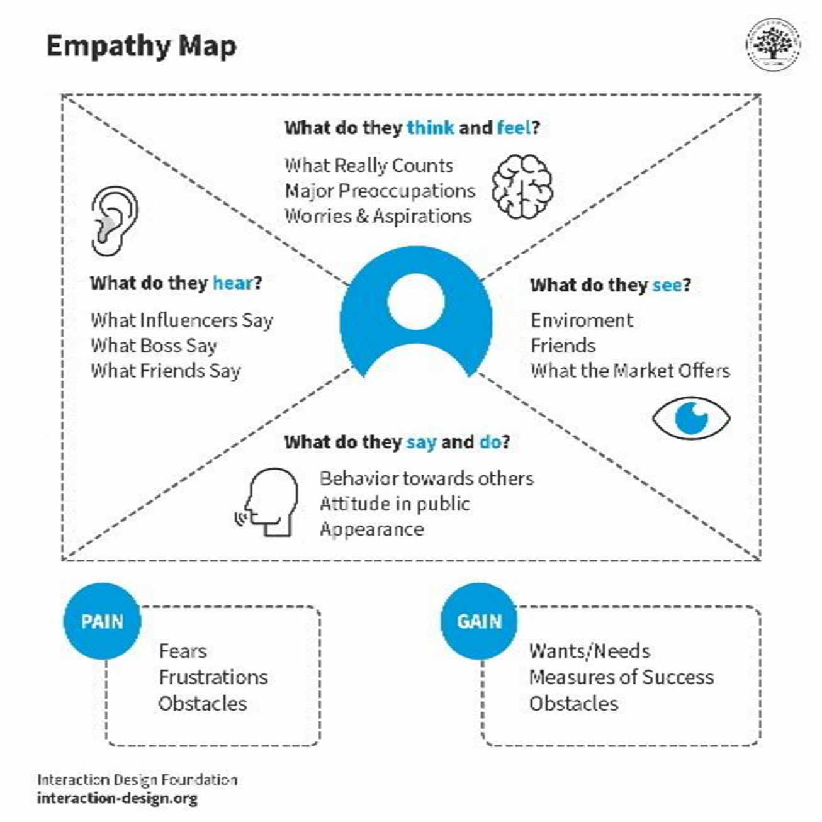

Reference: [https://www.mural.co/templates/empathy-map-canvas h](https://www.mural.co/templates/empathy-map-canvas)ttps://empathyimages.com

# Example: Buying a child’s first bike

